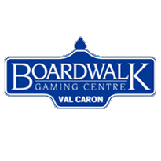

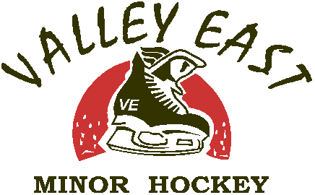
EVER WONDER….
HOW CAN I HELP?
VEMHA is a Boardwalk Gaming Center Charity
What does this mean for me? As a boardwalk gaming charity, the VEMHA receives monthly charitable earnings from a percentage of all sales at the Val Caron boardwalk gaming center. This fundraising opportunity is a major part of funding for our association, and a large part of how we keep our registration fees down. Last year alone we received $16000

Although this is a fantastic opportunity for our organization, it only works if we have people willing to volunteer a little of their time. We are looking for parents/guardians, grandparents, family members and friends willing to work our bingo sessions….all it takes is a short training session and a fabulous smile!!

For more information about the potential benefits to you please contact:
Stacy Cretzman at 588-2032 / vemhasecretary@gmail.com

