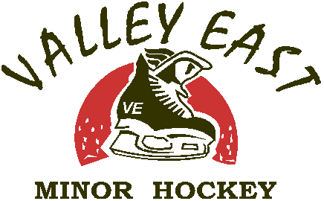
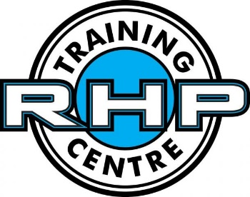
RHP Goalie Development
Valley East Minor Hockey Association is pleased to announce that we will be providing goalie training for the 2015/16 season. We as an Association believe that it is time that our goalies get some special treatment and this is why we have partnered with RHP to provide the goalies with some quality training. Not only do we want our goalies to develop but we want our coaches to also learn how to teach the goalies at their own practices. All teams will have to schedule a member of their coaching staff to attend these training sessions.
VEMHA has invested a lot for this training and this shows how serious we are about making our goalies better. We will also need the support of the teams and goalie parents. As part of the team budget, you will need to include $100 to help with this training. It is a minimal investment for a LARGE return. Goalies help win championships. As for the parents, they are being asked to give a $100 deposit, to be reimbursed at the end of the year providing you did not miss any sessions. Reasons for missing will be discussed with the parents and the board.
Now as for the RHP training.
RHP has a staff of professional instructors that have a great combination of playing and coaching experience. Goalie trainer Shawn Sirman has developed a series of progressions to have a detailed approach to teaching which allows any of the RHP staff to improve a beginner goaltender to a pro. RHP’s passion is coaching and bringing out the best in each individual goalie.
We will be sending 12 goalies and 6 coaches to the training session. VEMHA has every Tuesday at 7:30 for 1 Hour sessions from October 6th, 2015 to February 23^{rd,} 2016. It will be a 3:1 goalie to instructor ratio with Shawn Sirman also on the ice going from station to station and helping where needed. So there will be a total of 5 instructors on the ice for these sessions.
VEMHA is very proud to be able to provide this training for the goalies but it cannot be done without the support of the teams and the parents. This is a program that we want to continue but it is up to you guys to help us make this work.
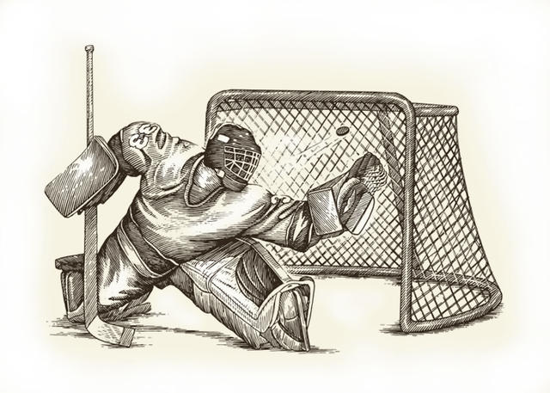
Your contact for this program will be Yves Lalonde and he can be reached by email bantamhockey@outlook.com or Cell 705-918-1499, nights only.

Thank you,
VEMHA

